**S1 details of encoding process**

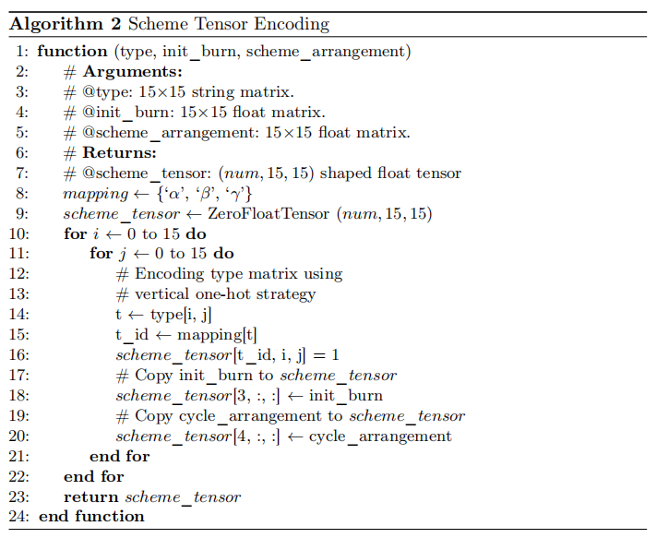

The other two attributes, i.e., the initial burnup and the arrangement can be both represented as 15 ×15 tensors. We concatenate these tensors vertically. to compose the tensor which represents areactor core fuel arrangement scheme. Figure 2shows the reactor core assembly tensor in detail. As we have three types of assemblies in this work, if all the fuels are new, the shape of the reactor core assembly arrangement tensor will be [num,15, 15]. The detailed procedure to convert a reactor core assembly arrangement to a tensor is shown in Algorithm 2.

Considering that the above non-NN-based machine learning methods only require features in one dimension, we flatten the reactor core tensors as the in- put of this method. Please note that as the proposed vertical one-hot encoding strategy is designed only for vertically stacked tensors, which severely increases the dimensions for these non-NN-based machine learning methods, we disabled the vertical one-hot strategy and map each assembly type to a scalar for representation of each reactor core layout.